**Midterm Lab Task 2   
Using Functions**

**Problem 1.**

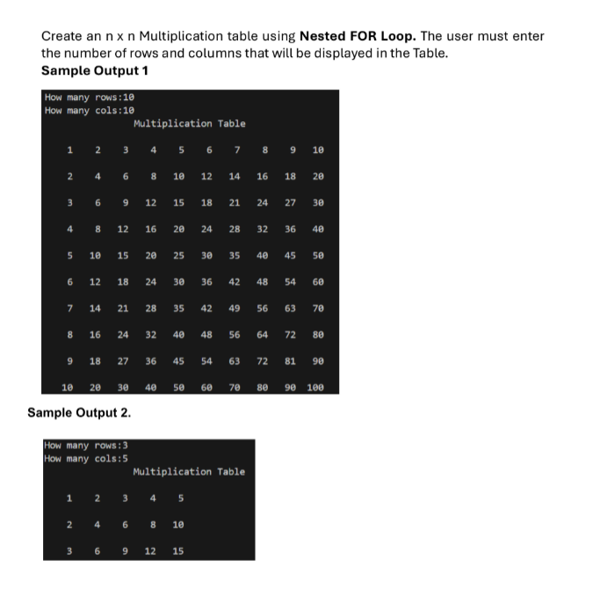

**Problem 2. Create a bank program that will allow the user to perform the ff: Use Functions as necessary**

